Job Application Form – Schools
Completed applications should be returned to the school at the following address:
Upper Wharfedale School

Wharfeside Avenue
Threshfield
Skipton
BD23 5BS
Applications can also be returned by e-mail to: admin@uws.n-yorks.sch.uk

SECTION 1 - POST DETAILS

Job Title: School Administrator Closing Date: 07/07/2024

Please write in capital letters in black ink or type, do not include a CV.

This application form has been designed to exclude information that might lead to discrimination. Please refer to the accompanying guidance notes when completing your application.

SECTION 2 - PERSONAL DETAILS

Title: | First forename:
Other forename: | Surname:
Former Surname: | Other names:
Address line 1: | Address line 2:
Town: | County:
Postcode: | Country:
Home Phone No.: | Resident at this address since (Date):
Mobile Number: | Work Number:
Email Address:

Please note correspondence regarding your application may be sent to your e-mail and/or postal address. Applicants who have not heard within 21 days of the closing date are thanked for their application and are asked to assume that it has been unsuccessful on this occasion.

SECTION 3 - PERSONAL DETAILS CONTINUED

Are there any restrictions to your residence in the UK which might affect your right to take up
employment in the UK? Yes No

If Yes, please provide details:

If you are successful in your application would you require a work permit or visa prior to taking up
employment? Yes No

Have you ever lived and/or worked outside of the UK? Yes No

If Yes, please provide details:

Do you hold a Certificate of Good Conduct for your time spent abroad? Yes No

If yes, please provide the country and date of issue:

Teaching staff only: Do you hold a letter of professional standing for any countries where you have worked as a teacher? Yes No

If yes, please provide the country and date of issue:

Insert your National Insurance Number:

SECTION 4 – SOURCE OF APPLICATION

Where did you see the vacancy advertised? Please specify:

SECTION 5 – SECONDARY EDUCATION

Detail here any qualifications held (continue on a separate sheet if necessary).

Subject | Qualification | Grade | Month and Year obtained (Mandatory)

SECTION 6 – FURTHER EDUCATION

Detail here any Further Education/Vocational/Professional Qualifications/Other Qualifications held or currently being studied (continue on a separate sheet if necessary).

School, College or University | Subject | Qualification/Level | Grade | Year Obtained /  Examination  Date

SECTION 7 – COURSES

Please give details of recent significant in-service training courses etc. attended. (Continue on a separate sheet if necessary). (Teaching Roles Only - Newly Qualified Teachers are invited to outline key elements of their course).

Organising Body | Nature/Title of Course | Dates

SECTION 8 – MEMBERSHIP OF PROFESSIONAL BODIES

Institute | Grade of Membership, Membership Number | Enrolment date | Examination date | Expiry date

SECTION 9 – REGISTERED COUNCILS

Are you registered with the Institute for Learning? Yes No

If you have answered Yes, please provide your Registration number

Teaching Roles only:
Teacher Reference Number:

Current salary point:

Date QTS awarded:

Induction period completed? | Yes No | Date of completion:
If you have answered No,  please select the appropriate option: | Not yet started Term 1 completed Term 2 completed Exempt

SECTION 10 – EMPLOYMENT DETAILS

Have you previously worked for or are currently working for North Yorkshire County Council? (An employee is defined as someone who is paid directly by NYCC and does not include those working in a voluntary capacity or via an agency)
Yes No

Manager’s name and job title: | Job Title:
Place of work: | Employment start date (Month/YYYY):
Employment end date (Month/YYYY)  (if applicable): | Reason for leaving (if applicable):
Number on roll (teaching roles only): | Age Range (teaching roles only):
Employee reference number:

SECTION 11 – PRESENT OR MOST RECENT EMPLOYMENT

Name of Employer:

Local Education Authority:

Address line 1: | Address line 2:
Town: | County:
Postcode: | Country:
Post held: | Grade:
Number on roll (teaching roles only): | Age Range (teaching roles only):
Date of appointment (Month/YYYY): | Salary:
Notice Required: Weeks/Months | Telephone number:
Leave date (if applicable- Month/YYYY): | Reason for leaving (if applicable):
Summary of current job role; duties and responsibilities

SECTION 12 – PREVIOUS EMPLOYMENT

List all your previous jobs (most recent first). Identify and account for any gaps in employment.

Name of Employer:
Address line 1: | Address line 2:
Town: | County:
Postcode: | Country:
Post held:
Job Role Summary:

Grade / Salary: | Date from (Month/YYYY):
Date to (Month/YYYY): | Reason for leaving (if applicable):
Name of Employer
Address line 1: | Address line 2:
Town: | County:
Postcode: | Country:
Post held:
Job Role Summary:

Grade / Salary: | Date from (Month/YYYY):
Date to (Month/YYYY): | Reason of leaving (if applicable):
Name of Employer:
Address line 1: | Address line 2:
Town: | County:
Postcode: | Country:
Post held:
Job Role Summary:

Grade / Salary: | Date from (Month/YYYY):
Date to (Month/YYYY): | Reason of leaving (if applicable):
Name of Employer:
Address line 1: | Address line 2:
Town: | County:
Postcode: | Country:
Post held:
Job Role Summary:

Grade / Salary: | Date from (Month/YYYY):
Date to (Month/YYYY): | Reason of leaving (if applicable):
Please provide details for any gaps in your employment history when you have not been in education, training or employment.
Please list dates and the reason (i.e. travel, parental leave, etc.)
Gaps in employment (including dates (Month/YYYY))

SECTION 13 – REFERENCE OF PRESENT OR MOST RECENT EMPLOYMENT

Please give the name and addresses of two referees (not relatives) one of whom should be your present employer (or last employer if not currently employed). If you are in, or have just completed, full time education, one referee should be from your College/University.

Title: | First forename:
Other forename: | Surname:
Address line 1: | Address line 2:
Town: | County:
Postcode: | Country:
Telephone number: | Email address:
Occupation:

Relationship to you? | Do you give permission for referees to be contacted prior to an offer of employment being made?
 | Yes |  | No

Please note your referee should ideally be a previous line manager or someone in a position of authority.

SECTION 14 – REFERENCES

Title: | First forename:
Other forename: | Surname:
Address line 1: | Address line 2:
Town: | County:
Postcode: | Country:
Telephone number: | Email address:
Occupation:

Relationship to you? | Do you give permission for referees to be contacted prior to an offer of employment being made?
 | Yes |  | No

SECTION 15 – DECLARATIONS AND CONSENTS

Are there any reasonable adjustments that you would require to enable you to participate in the interview/assessment event if you were selected to attend?

Are you related to any member or employee of the County Council? | Yes | No
If you answered ‘Yes’, please provide details

Are you related to a member of the School Governing Body? | Yes | No
If ‘Yes’, please provide name(s) & relationship:

I understand that canvassing of any Governors,  Members or Officers of North Yorkshire County Council in connection with this appointment will disqualify me. | Yes No

Has any previous employer expressed concerns and/or taken any action, whether informal/ formal (including suspension from duty) on the following: (Include any investigations or actions taken by your professional body)

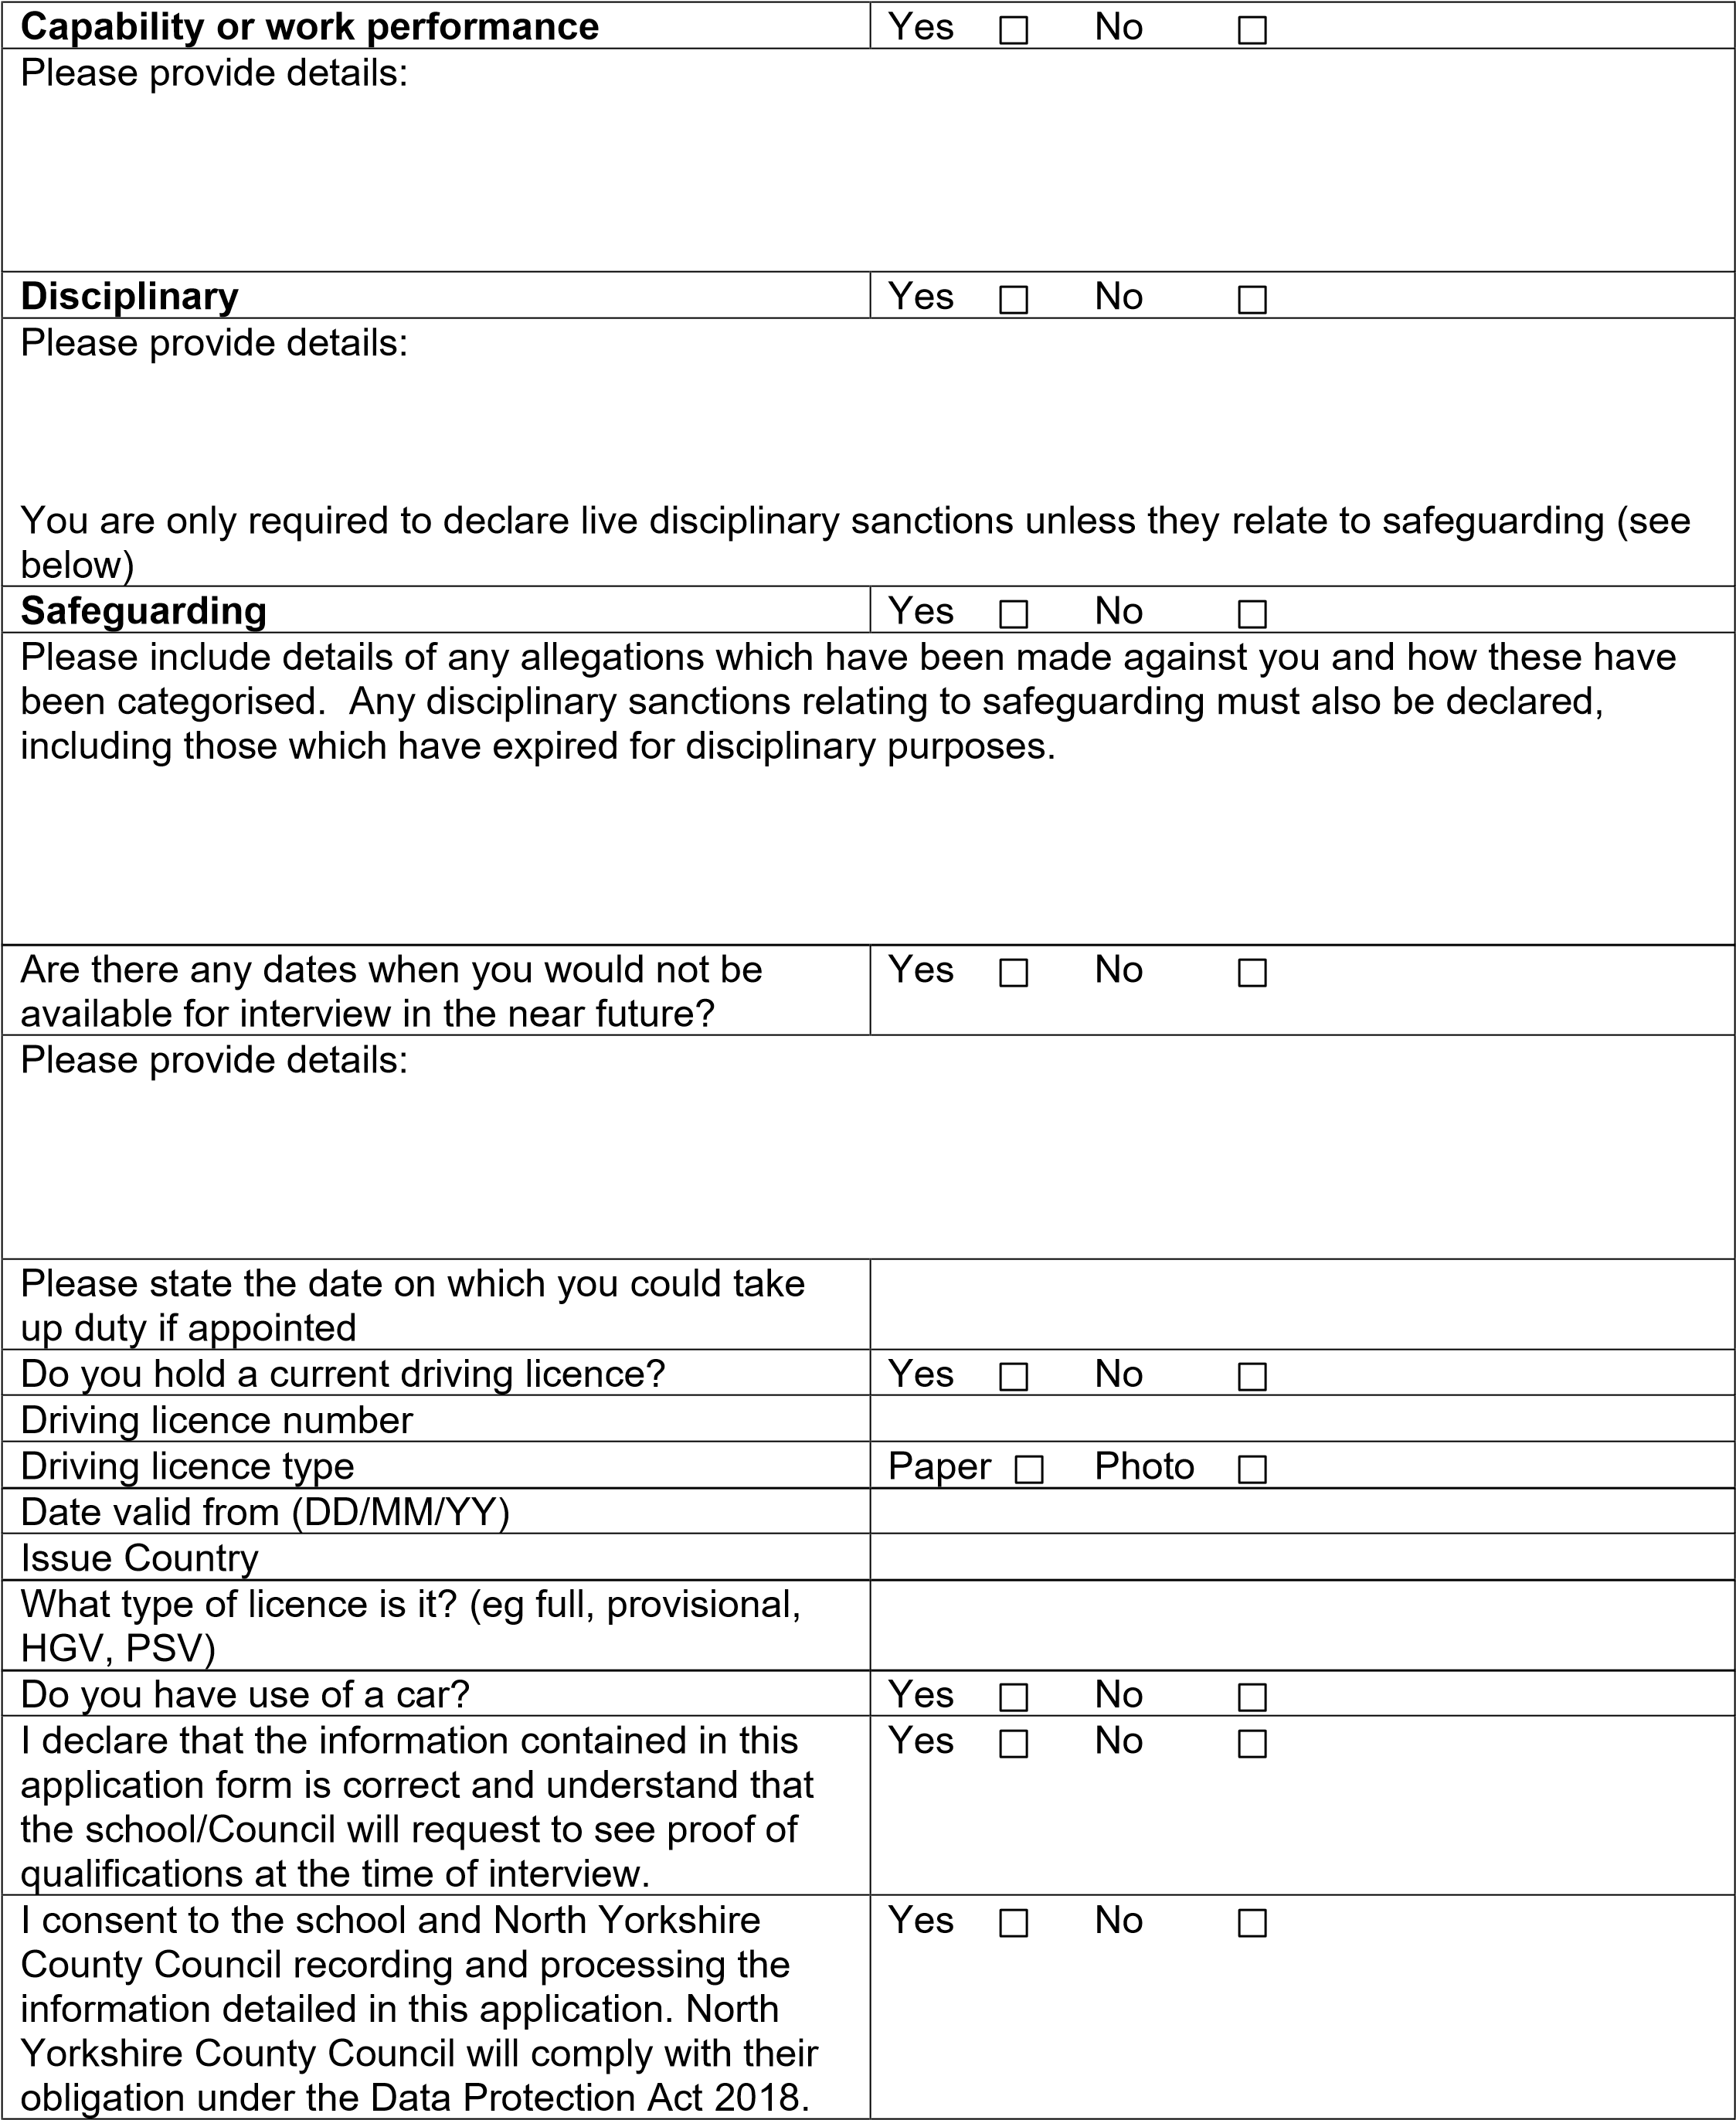

SECTION 16 – SUPPORTING EVIDENCE

Please ensure that you have read carefully the job description and person specification for the role that you are applying for, and provide a separate letter detailing how your knowledge, skills and experience evidence that you meet the requirements for this post as detailed in the person specification and advertisement. Shortlisting and appointment to this post will be based on your ability to meet these requirements.

If you submit this form via email you are declaring that the information stated is true and accurate.
I confirm that the information that I have provided in support of this application is complete and true and understand that knowingly to make a false statement for this purpose will be judged as serious misconduct, which may result in dismissal, or may be a criminal offence.

Signature: ………………………………………………………...Dated:…………………………...

Please return all completed applications to the school address

SECTION 17 – EQUAL OPPORTUNITIES MONITORING

North Yorkshire County Council is committed to equality in employment. The Council’s aim is to ensure equality for all existing and prospective employees. In line with this North Yorkshire County Council are required to publish work force data.

In order to assist the Council with this aim please provide the information below in monitoring recruitment procedures for which your co-operation would be appreciated.

The information will not form part of our short listing, and will be separated from your application form upon receipt. The information provided will be used for statistical and monitoring purposes and to help us to develop our policies and practice and will be treated confidentially and be subject to the provisions under the current Equality Legislation and Data Protection Act.

Applicant name
Post applied for
Closing date
Gender |  | Male Female
 |  | Prefer not to disclose
Please note: the categories below are taken from the 2001 Census. The Council is required to use this format for its monitoring exercises.
What is your ethnic group? |  | White British White Irish  White Other Mixed: White and Black  Mixed: White and Black African  Mixed: White and Asian  Asian or Asian British  Asian or Asian British: Indian  Asian or Asian British: Pakistani  Asian or Asian British: Bangladeshi  Asian or Asian British: Other Asian  Black or Black British: Caribbean  Black or Black British: African  Black or Black British: Other Black  Chinese or Other Ethnic Group
 |  | Other
Please specify
Do you consider yourself to have a disability as described by the Equality Act 2010? |  | Yes |  |  | No
Date of birth*

* For successful candidates only, this information will be used as part of pre-employment vetting checks to assist in the confirmation of identify.

APPLYING FOR A JOB WITH NORTH YORKSHIRE COUNTY COUNCIL

IMPORTANT ADVICE ON COMPLETING THIS APPLICATION

Your application form plays an important part in your selection. Please ensure you address all the essential requirements listed in the specifications. The following advice should help you to complete the application form as effectively as possible.

Data Protection
The information that you state on this application form will be used by the school and the Council to consider you for a job vacancy. To find out about how we use your personal data for the purposes of recruitment please see our Privacy Notice at www.northyorks.gov.uk/working-us.

Rehabilitation of Offenders
The post you are applying for requires you to have an enhanced Disclosure and Barring Service criminal records check for work with children, with a barred list check if you work in regulated activity. This check for disclosure of criminal history will include spent convictions, pending prosecutions / current court proceeding and police enquiries.

Should you be shortlisted, you will be asked to disclose details of your criminal history, in line with DBS filtering rules, prior to your interview. This information may be discussed with you at your interview in order to assess job related risks, but we emphasise that your application will be considered on merit and ability and you will not be discriminated against unfairly. Failure to disclose this information will result in any offer of employment being withdrawn.

Please also see the policy statement on the Recruitment of Ex-offenders below.

Information in Support of your Application
Every post advertised is supported by a full person specification. The specification lists all the essential skills, experience and qualifications which are necessary for the job and the criteria against which you will be assessed, both through your application form and at interview.

As part of the application process, you may have been asked to demonstrate within this application form how you meet some or all of the criteria or key competencies outlined in the person specification. Rather than simply repeating your career history, look at the skills and experience required by the job and provide evidence that you possess them by giving specific and detailed examples which include a focus on outcomes and on your own contribution to the scenario. Try to use different and varied examples wherever possible.

When completing these sections, do not forget the skills and experience you have gained outside fulltime work. Outlining your previous work experience or other responsibilities may help you to uncover skills which you have taken for granted and which are clear signs of your ability to do the job.

Canvassing
You must not try to influence an elected Council Member, any council employee or a member of the school governing body, to act in your favour, as this will disqualify you. If you are related to a Councillor, a Council employee or a governor you must indicate this in the relevant section of the application form.

Policy Statement on the Recruitment of Ex-offenders

- As an organisation assessing applicants’ suitability for positions which are included in the Rehabilitation of Offenders Act 1974 (Exceptions) Order using criminal record checks processed through the Disclosure and Barring Service (DBS), this school complies fully with the DBS code of practice and undertakes to treat all applicants for positions fairly.

- This school undertakes not to discriminate unfairly against any subject of a criminal record check on the basis of a conviction or other information revealed.
- This school can only ask an individual to provide details of convictions and cautions that it is legally entitled to know about. Where a DBS certificate can legally be requested (where the position is one that is included in the Rehabilitation of Offenders Act 1974 (Exceptions) order 1975 as amended, and where appropriate Police Act Regulations as amended) this school can only ask an individual about convictions and cautions that are not protected.

- This school is committed to the fair treatment of its staff and potential staff, regardless of race, gender, religion, sexual orientation, responsibilities for dependents, age, physical/mental disability or offending background.

- This school has this written policy on the recruitment of ex-offenders, which is made available to all DBS applicants at the start of the recruitment process.

- This school actively promotes equality of opportunity for all with the right mix of talent, skills and potential and welcome applications from a wide range of candidates, including those with criminal records. Candidates are selected for interview based on their skills, qualifications and experience and criminal record information is only requested from short-listed candidates.
- A disclosure is only requested from the DBS after a thorough risk assessment has indicated that one is both proportionate and relevant to the position concerned. For those positions where a criminal record check is identified as necessary, all application forms, job adverts and recruitment briefs will contain a statement that a DBS certificate will be requested in the event of the individual being offered the position.

- This school ensures that all those who are involved in the recruitment process have been suitably trained to identify and assess the relevance and circumstances of offences.

- This school also ensures that they have received appropriate guidance and training in the relevant legislation relating to the employment of ex-offenders, e.g. the Rehabilitation of Offenders Act 1974.

- At interview, or in a separate discussion, this school ensures that an open and measured discussion takes place on the subject of any offences or other matter that might be relevant to the position. Failure to reveal information that is directly relevant to the position sought could lead to withdrawal of an offer of employment.

- This school makes every subject of a criminal record check submitted to DBS aware of the existence of the code of practice and makes a copy available on request.

- This school undertakes to discuss any matter revealed on a DBS certificate with the individual seeking the position before withdrawing a conditional offer of employment.

(Source www.gov.uk)

